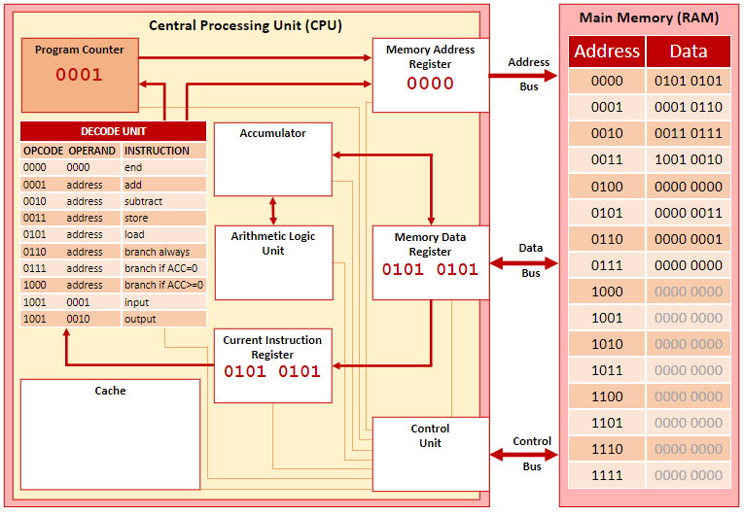

Fetch – the MAR fetches instruction from program counter
Goes through the ram using the address bus
Control unit controlling the flow of data
Moves to the MDR, then the CIR
Increments the pc

Decode –
Decode unit decodes whatever’s in the cir
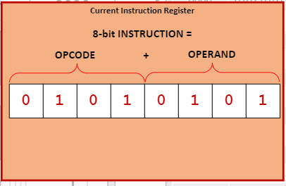
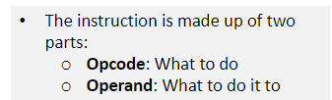

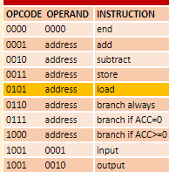
Execute
Takes whatever instruction we need,
Sends it back through the cycle of pc – MDR
Goes to accumulator instead, which connects to the alu
Acc results are stored in the alu

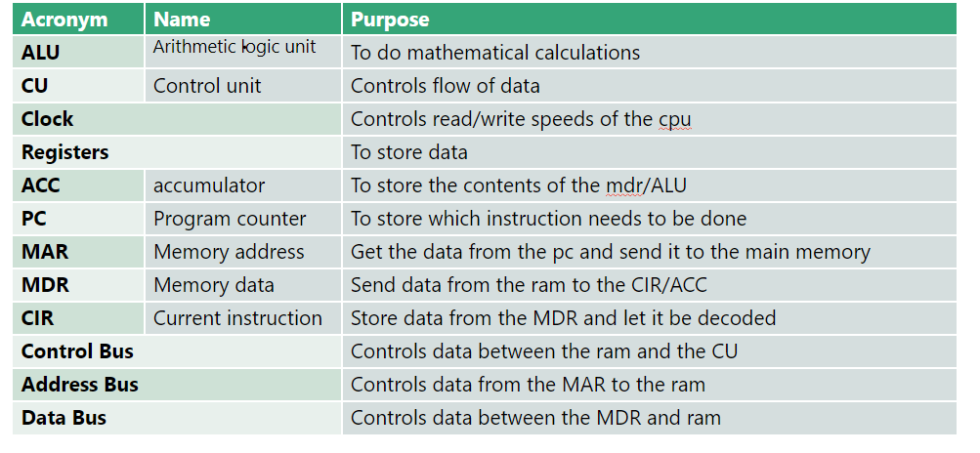

TWO DIFFERENT TYPES OF RAM
Static ram – more expensive, higher energy consumption, doesn’t need to be refreshed
Only placed in the motherboard
Dynamic ram – less expensive, lower energy consumption, doesn’t need to be refreshed
Can go in motherboards and in expansion cards i.e. SD cards

PIPELING
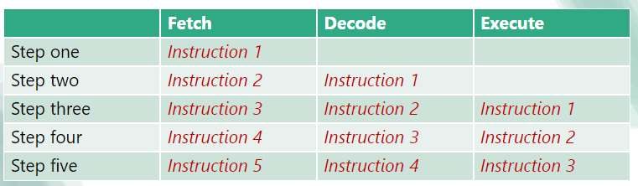
Does multiple instructions in parallel, creating more efficiency
Does not like selection, when data from previous instructions is needed for progression

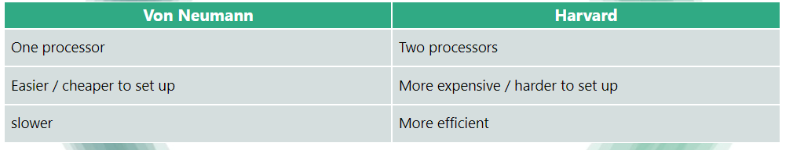

2 different types of pipelining
Arithmetic
instruction

2026:
Program counter, stores address of the next instruction
Current instruction register, stores current instruction, split into opcode and operand
Memory address register, stores address of the location for current instruction
Memory data register, temporarily stores data from or to memory

